Part III: Trunking
Chapter 8 Trunking Technologies and Applications
Chapter 9 Trunking with LAN Emulation
Chapter 10 Trunking with Multiprotocol over ATM

Chapter 8. Trunking Technologies and Applications
This chapter covers the following key topics:
- Why Trunks?—
Describes the advantages of trunks and compares various trunk connection methods for interconnecting Catalysts, routers, and servers.
- Ethernet Trunks—
Details the trunk options over Fast Ethernet and Gigabit Ethernet. EtherChannel technologies are also discussed. Also describes ISL and 802.1Q encapsulation over trunks. Automatic methods of establishing trunks through DISL and DTP are also considered.
- FDDI Trunks and 802.10 Encapsulation—
Provides an overview of trunking technology over FDDI in a Cisco environment and the associated encapsulation technology, 802.10.
- ATM Trunks—
Offers an overview of LANE and MPOA for trunking over ATM. Both LANE and MPOA are detailed in subsequent chapters.
- Trunk Options—
Provides guidelines for choosing an appropriate trunk technology by comparing the advantages and disadvantages of each.
Except for the simplest of network configurations, a network comprises multiple Catalysts. Although each Catalyst can stand autonomously, they usually interconnect through ATM, FDDI, or Ethernet technologies. Administrators often face the challenge of choosing the best method to interconnect geographically disbursed members of a VLAN. Some of the issues involved in the decision include the following: technology availability, resources, bandwidth, and resiliency.
This chapter reviews the advantages of trunks and discusses the various technologies available for Catalyst trunks. Specifically, the following sections describe trunks for Fast and Gigabit Ethernet, FDDI, and ATM. The sections also explain Inter-Switch Link (ISL), 802.1Q, Dynamic ISL (DISL), Dynamic Trunk Protocol (DTP), Token Ring ISL (TRISL), 802.10, LAN Emulation (LANE), and Multiprotocol over ATM (MPOA). Guidelines for choosing a method are included at the end of the chapter.

Why Trunks?
When all of the Catalysts in a network support one VLAN and need connectivity, you can establish links between the Catalysts to transport intra-VLAN traffic. One approach to interconnecting Catalysts uses links dedicated to individual VLANs. For example, the network in Figure 8-1 connects several Catalysts together. All of the Catalyst configurations include only one VLAN—all ports belong to the same VLAN. Catalysts A and B interconnect with two direct links for resiliency. If one link fails, Spanning Tree enables the second link.

Figure 8-1 A Single VLAN Catalyst Design
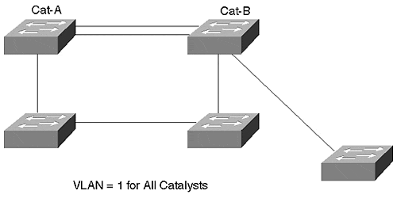
When you dedicate a link to a single VLAN, this is called an access link. Access links never carry traffic from more than one VLAN. You can build an entire switched network with access links. But as you add VLANs, dedicated links consume additional ports in your network when you extend the VLAN to other switches.
In Figure 8-1, multiple links interconnect the Catalysts, but each link belongs to only 1 VLAN. This is possible because there is only one VLAN in the network. What if there were more than one? To interconnect multiple VLANs, you need a link for each VLAN. The network in Figure 8-2 interconnects six Catalysts and contains three distributed VLANs. Notice that Cat-B has members of all three VLANs, whereas its neighbors only have members of two VLANs. Even though the neighbors do not have members of all VLANs, an access link for all three VLANs is necessary to support Cat-B. Without the VLAN 3 access links attached to Cat-B, VLAN 3 members attached to Cat-B are isolated from VLAN 3 members on other Catalysts.

Figure 8-2 A Multi-VLAN Network Without Trunks
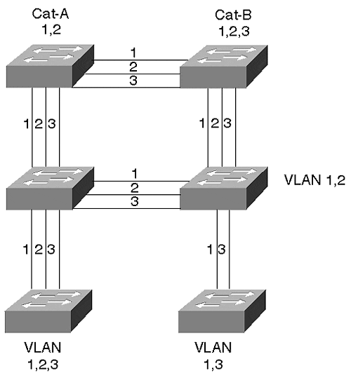
When deploying a network with access links, each link supplies dedicated bandwidth to the VLAN. The link could be a standard 10-Mbps link, a Fast Ethernet, or even a Gigabit Ethernet link. You can select the link speed appropriate for your VLAN requirements. Further, the link for each VLAN can differ. You can install a 10-Mbps link for VLAN 1 and a 100-Mbps link for VLAN 2.
Unfortunately, access links do not scale well as you increase the number of VLANs or switches in your network. For example, the network of Figure 8-1 uses 34 interfaces and 17 links to interconnect the VLANs. Imagine if there were 20 switches in the network with multiple VLANs. Not only does your system cost escalate, but your physical layer tasks as an administrator quickly become unbearable as the system expands.
Alternatively, you can enable a trunk link between Catalysts. Trunks allow you to distribute VLAN connectivity without needing to use as many interfaces and cables. This saves you cost and administrative headaches. A trunk multiplexes traffic from multiple VLANs over a single link. Figure 8-3 illustrates the network from Figure 8-2 deployed with trunks.

Figure 8-3 The Figure 8-2 Network with Trunk Links
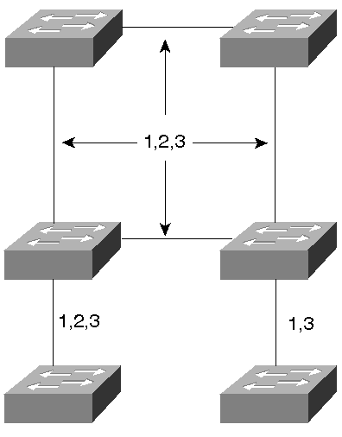
In this network, only 12 ports and six links are used. Although VLANs share the link bandwidth, you conserve capital resources in your network by sharing the links. The majority of this chapter focuses on connectivity between switches. As a practical introduction to trunks, the following section describes reasons to attach routers and file servers to switches with trunks.

Trunks, Servers, and Routers
Trunks are not limited to use between Catalysts. They can also connect routers and file servers to switches. You can do this to support multiple VLANs without using additional ports (see Figure 8-4).

Figure 8-4 Connecting File Servers and Routers in a Multi-VLAN Network
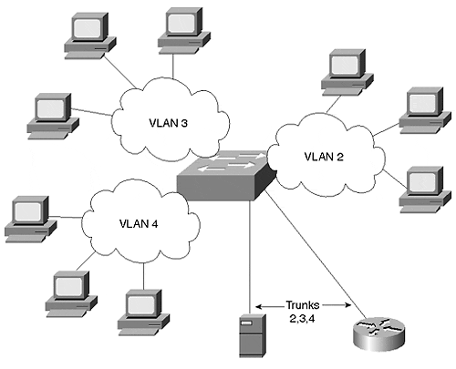
In Figure 8-4, workstations belong to VLANs 2, 3, and 4. Because these stations attach to different broadcast domains, they cannot communicate with each other except through a router. Trunks connect a file server and a router to the switched network. The trunk connection to the router enables inter-VLAN connectivity. Without trunks, you can use multiple interfaces on the router and attach each to a different port on the switch as in Figure 8-5. The difficulty you might experience, though, is in the number of VLANs that this configuration supports. If the connections are high-speed interfaces like Fast Ethernet, you might only install a couple of interfaces. If you use 10-Mbps interfaces, you might not have the bandwidth that you want to support the VLANs.

Figure 8-5 A Brute Force Method of Attaching Routers and Servers to Multiple VLANs
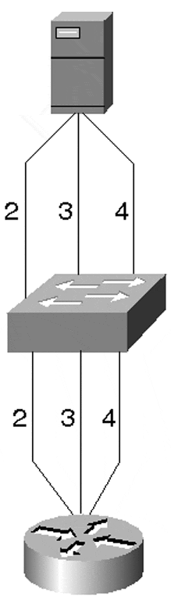
Likewise, you could attach a file server to more than one VLAN through multiple interface cards. As when interconnecting switches with dedicated links, this does not scale well and costs more than a trunk link. Therefore, the trunk connectivity used in Figure 8-4 is usually more reasonable.
When a router or file server attaches as a trunk to the switch, it must understand how to identify data from each of the VLANs. The router must, therefore, understand the multiplexing technique used on the link. In a Cisco environment, this can be either ISL or 802.1Q over Ethernet, 802.10 over FDDI, or LANE/MPOA over ATM. In a mixed vendor environment, you must trunk with 802.1Q or LANE/MPOA.
Note
Some vendors such as Intel and others supply ISL-aware adapter cards for workstations allowing you to use Cisco's trunk protocols. This is beneficial if you want to attach a file server to the Catalyst using a trunk link rather than multiple access links.

Ethernet Trunks
Most trunk implementations use Ethernet. You can construct Ethernet trunks using Fast Ethernet or Gigabit Ethernet, depending upon your bandwidth needs. EtherChannel (defined in greater detail in the sections that follow) creates additional bandwidth options by combining multiple Fast Ethernet or Gigabit Ethernet links. The combined links behave as a single interface, load distribute frames across each segment in the EtherChannel, and provide link resiliency.
Simply inter-connecting Catalysts with Ethernet does not create trunks. By default, you create an access link when you establish an Ethernet interconnection. When the port belongs to a single VLAN, the connection is not a trunk in the true sense as this connection never carries traffic from more than one VLAN.
To make a trunk, you must not only create a link, but you must enable trunk processes. To trunk over Ethernet between Catalysts, Cisco developed a protocol to multiplex VLAN traffic. The multiplexing scheme encapsulates user data and identifies the source VLAN for each frame. The protocol, called Inter-Switch Link (ISL), enables multiple VLANs to share a virtual link such that the receiving Catalyst knows in what VLAN to constrain the packet.
Tip
Trunks allow you to more easily scale your network than access links. However, be aware that Layer 2 broadcast loops (normally eliminated with Spanning Tree) for a VLAN carried on a trunk degrades all VLANs on the trunk. Be sure to enable Spanning Tree for all VLANs when using trunks.

The following sections describe EtherChannel and ISL. The physical layer aspects of EtherChannel are covered first followed by a discussion of ISL encapsulation.

EtherChannel
EtherChannel provides you with incremental trunk speeds between Fast Ethernet and Gigabit Ethernet, or even at speeds greater than Gigabit Ethernet. Without EtherChannel, your connectivity options are limited to the specific line rates of the interface. If you want more than the speed offered by a Fast Ethernet port, you need to add a Gigabit Ethernet module and immediately jump to this higher-speed technology. You do not have any intermediate speed options. Alternatively, you can create multiple parallel trunk links, but Spanning Tree normally treats these as a loop and shuts down all but one link to eliminate the loop. You can modify Spanning Tree to keep links open for some VLANs and not others, but this requires significant configurations on your part.
EtherChannel, on the other hand, allows you to build incremental speed links without having to incorporate another technology. It provides you with some link speed scaling options by effectively merging or bundling the Fast Ethernet or Gigabit Ethernet links and making the Catalyst or router use the merged ports as a single port. This simplifies Spanning Tree while still providing resiliency. EtherChannel resiliency is described later. Further, if you want to get speeds greater than 1 Gbps, you can create Gigabit EtherChannels by merging Gigabit Ethernet ports into an EtherChannel. With a Catalyst 6000 family device, this lets you create bundles up to 8 Gbps (16 Gbps full duplex).
Unlike the multiple Spanning Tree option just described, EtherChannel treats the bundle of links as a single Spanning Tree port and does not create loops. This reduces much of your configuration requirements simplifying your job.
EtherChannel works as an access or trunk link. In either case, EtherChannel offers more bandwidth than any single segment in the EtherChannel. EtherChannel combines multiple Fast Ethernet or Gigabit Ethernet segments to offer more apparent bandwidth than any of the individual links. It also provides link resiliency. EtherChannel bundles segments in groups of two, four, or eight. Two links provide twice the aggregate bandwidth of a single link, and a bundle of four offers four times the aggregate bandwidth. For example, a bundle of two Fast Ethernet interfaces creates a 400-Mbps link (in full-duplex mode). This enables you to scale links at rates between Fast Ethernet and Gigabit Ethernet. Bundling Gigabit Ethernet interfaces exceeds the speed of a single Gigabit Ethernet interface. A bundle of four Gigabit Ethernet interfaces can offer up to 8 Gbps of bandwidth. Note that the actual line rate of each segment remains at its native speed. The clock rate does not change as a result of bundling segments. The two Fast Ethernet ports comprising the 400-Mbps EtherChannel each operate at 100 Mbps (in each direction). The combining of the two ports does not create a single 200-Mbps connection. This is a frequently misunderstood aspect of EtherChannel technology.
EtherChannel operates as either an access or trunk link. Regardless of the mode in which the link is configured, the basic EtherChannel operation remains the same. From a Spanning Tree point of view, an EtherChannel is treated as a single port rather than multiple ports. When Spanning Tree places an EtherChannel in either the Forward or Blocking state, it puts all of the segments in the EtherChannel in the same state.

Bundling Ports
When bundling ports for EtherChannel using early EtherChannel-capable line modules, you must follow a couple of rules:
- Bundle two or four ports.
- Use contiguous ports for a bundle.
- All ports must belong to the same VLAN. If the ports are used for trunks, all ports must be set as a trunk.
- If you set the ports to trunk, make sure that all ports pass the same VLANs.
- Ensure that all ports at both ends have the same speed and duplex settings.
- You cannot arbitrarily select ports to bundle. See the following descriptions for guidelines.
These rules are generally applicable to many EtherChannel capable modules, however, some exceptions exist with later Catalyst modules. For example, the Catalyst 6000 line cards do not constrain you to use even numbers of links. You can create bundles with three links if you so choose. Nor do the ports have to be contiguous, or even on the same line card, as is true with some Catalyst devices and line modules. The previously mentioned exceptions of the Catalyst 6000 EtherChannel rules come from newer chipsets on the line modules. These newer chips are not present on all hardware. Be sure to check your hardware features before attempting to create any of these other bundle types.
Early EtherChannel-capable modules incorporate a chip called the Ethernet Bundling Controller (EBC) which manages aggregated EtherChannel ports. For example, the EBC manages traffic distribution across each segment in the bundled link. The distribution mechanism is described later in this section.
When selecting ports to group for an EtherChannel, you must select ports that belong to the same EBC. On a 24-port EtherChannel capable module, there are three groups of eight ports. On a 12-port EtherChannel capable module, there are three groups of four ports.
Table 8-1 shows 24- and 12-port groupings.

Table 8-1. 24-Port and 12-Port Groupings for EtherChannel
1 | 2 | 3 | 4 | 5 | 6 | 7 | 8 | 9 | 10 | 11 | 12 | 13 | 14 | 15 | 16 | 17 | 18 | 19 | 20 | 21 | 22 | 23 | 24
1 | 1 | 1 | 1 | 1 | 1 | 1 | 1 | 2 | 2 | 2 | 2 | 2 | 2 | 2 | 2 | 3 | 3 | 3 | 3 | 3 | 3 | 3 | 3
1 | 1 | 1 | 1 | 2 | 2 | 2 | 2 | 3 | 3 | 3 | 3

Table 8-2. Valid and Invalid 12-Port EtherChannel Examples (for Original Catalyst 5000 Implementations)
Port |  | 1 | 2 | 3 | 4 | 5 | 6 | 7 | 8 | 9 | 10 | 11 | 12
Example A | OK | 1 | 1 | 2 | 2 | 3 | 3 | 4 | 4 | 5 | 5 | 6 | 6
Example B | OK | 1 | 1 |  |  | 2 | 2 |  |  | 3 | 3
Example C | OK | 1 | 1 | 1 | 1 | 2 | 2
Example D | NOK |  |  | 1 | 1
Example E | NOK | 1 | 1 | 2 | 2 | 2 | 2
Example F | NOK | 1 |  | 1
Example G | NOK |  | 1 | 1
For example, in a 12-port module, you can create up to two dual segment EtherChannels within each group as illustrated in Example A of Table 8-2. Or, you can create one dual segment EtherChannel within each group as in Example B of Table 8-2. Example C illustrates a four-segment and a two-segment EtherChannel.
You must avoid some EtherChannel configurations on early Catalyst 5000 equipment. Example D of Table 8-2 illustrates an invalid two-segment EtherChannel using Ports 3 and 4 of a group. The EBC must start its bundling with the first ports of a group. This does not mean that you have to use the first group. In contrast, a valid dual segment EtherChannel can use Ports 5 and 6 with no EtherChannel on the first group.
Example E illustrates another invalid configuration. In this example, two EtherChannels are formed. One is a dual-segment EtherChannel, the other is a four-segment EtherChannel. The dual-segment EtherChannel is valid. The four-segment EtherChannel, however, violates the rule that all ports must belong to the same group. This EtherChannel uses two ports from the first group and two ports from the second group.
Example F shows an invalid configuration where an EtherChannel is formed with discontiguous segments. You must use adjacent ports to form an EtherChannel.
Finally, Example G shows an invalid EtherChannel because it does not use the first ports on the module to start the EtherChannel. You cannot start the EtherChannel with middle ports on the line module.
All of the examples in Table 8-2 apply to the 24-port modules too. The only difference between a 12- and 24-port module is the number of EtherChannels that can be formed within a group. The 12-port module allows only two EtherChannels in a group, whereas the 24-port module supports up to four EtherChannels per group.
One significant reason for constraining bundles within an EBC stems from the load distribution that the EBC performs. The EBC distributes frames across the segments of an EtherChannel based upon the source and destination MAC addresses of the frame. This is accomplished through an Exclusive OR (X-OR) operation. X-OR differs from a normal OR operation. OR states that when at least one of two bits is set to a 1, the result is a 1. X-OR means that when two bits are compared, at least one bit, but only one bit can have a value of 1. Otherwise, the result is a 0. This is illustrated in Table 8-3.

Table 8-3. Exclusive-OR Truth Table
Bit-1 | Bit-2 | Result
0 | 0 | 0
0 | 1 | 1
1 | 0 | 1
1 | 1 | 0
The EBC uses X-OR to determine over what segment of an EtherChannel bundle to transmit a frame. If the EtherChannel is a two-segment bundle, the EBC performs an X-OR on the last bit of the source and destination MAC address to determine what link to use. If the X-OR generates a 0, segment 1 is used. If the X-OR generates a 1, segment 2 is used. Table 8-4 shows this operation.

Table 8-4. Two-Segment Link Selection
MAC | Binary of Last Octet | Segment Used
Example 1
MAC Address 1 | xxxxxxx0
MAC Address 2 | xxxxxxx0
X-OR | xxxxxxx0 | 1
Example 2
MAC Address 1 | xxxxxxx0
MAC Address 2 | xxxxxxx1
X-OR | xxxxxxx1 | 2
Example 3
MAC Address 1 | xxxxxxx1
MAC Address 2 | xxxxxxx1
X-OR | xxxxxxx0 | 1
The middle column denotes a binary representation of the last octet of the MAC address. An x indicates that the value of that bit does not matter. For a two-segment link, only the last bit matters. Note that the first column only states Address 1 or Address 2. It does not specify which is the source or destination address. X-OR produces exactly the same result regardless of which is first. Therefore, Example 2 really indicates two situations: one where the source address ends with a 0 and the destination address ends in a 1, and the inverse. Frames between devices use the same link in both directions.
A four-segment operation performs an X-OR on the last two bits of the source and destination MAC address. An X-OR of the last two bits yields four possible results. As with the two-segment example, the X-OR result specifies the segment that the frame travels. Table 8-5 illustrates the X-OR process for a four-segment EtherChannel.
Note
Newer Catalyst models such as the 6000 series have the ability to perform the load distribution on just the source address, the destination address, or both. Further, they have the ability to use the IP address or the MAC addresses for the X-OR operation.
Some other models such as the 2900 Series XL perform X-OR on either the source or the destination MAC address, but not on the address pair.

Table 8-5. Four-Segment Link Selection
MAC | Binary of Last Octet | Segment Used
Example 1
MAC Address 1 | xxxxxxx00
MAC Address 2 | xxxxxxx00
X-OR | xxxxxxx00 | 1
Example 2
MAC Address 1 | xxxxxxx00
MAC Address 2 | xxxxxxx10
X-OR | xxxxxxx01 | 2
Example 3
MAC Address 1 | xxxxxxx01
MAC Address 2 | xxxxxxx10
X-OR | xxxxxxx10 | 3
Example 4
MAC Address 1 | xxxxxx01
MAC Address 2 | xxxxxx10
X-OR | xxxxxx11 | 4
Example 5
MAC Address 1 | xxxxxx11
MAC Address 2 | xxxxxx11
X-OR | xxxxxx00 | 1
The results of Examples 1 and 5 force the Catalyst to use Segment 1 in both cases because the X-OR process yields a 0.
The end result of the X-OR process forces a source/destination address pair to use the same link for each frame they transmit. What prevents a single segment from becoming overwhelmed with traffic? Statistics. Statistically, the MAC address assignments are fairly random in the network. A link does not likely experience a traffic loading imbalance due to source/destination MAC address values. Because the source and destination use the same MAC address for every frame between each other, the frames always use the same EtherChannel segment. It is possible, too, that a workstation pair can create a high volume of traffic creating a load imbalance due to their application. The X-OR process does not remedy this situation because it is not application aware.
Tip
Connecting RSMs together with a Catalyst EtherChannel might not experience load distribution. This occurs because the RSM MAC addresses remain the same for every transmission, forcing the X-OR to use the same segment in the bundle for each frame. However, you can force the RSM to use multiple user-assigned MAC addresses, one for each VLAN, with the mac-address command. This forces the switch to perform the X-OR on a per-VLAN basis and enable a level of load distribution.

Configuring EtherChannel and PAgP
To simplify the configuration of EtherChannel, Cisco created the Port Aggregation Protocol (PAgP). This protocol helps to automatically form an EtherChannel between two Catalysts. PAgP can have any of four states: on, off, auto, desirable. You specify which PAgP state the Catalyst should enable when you configure EtherChannel. Example 8-1 shows the syntax to create an EtherChannel and determine the PAgP mode.

Example 8-1 EtherChannel Syntax Example
Console> (enable) set port channel ? Usage: set port channel port_list {on|off|auto|desirable} (example of port_list: 2/1-4 or 2/1-2 or 2/5,2/6)
The set port channel command enables EtherChannel. It does not establish a trunk. With only this configuration statement, a single VLAN crosses the EtherChannel. To enable a trunk, you must also enter a set trunk command. The set trunk command is described in following sections.
The on and off options indicate that the Catalyst always (or never) bundles the ports as an EtherChannel. The desirable option tells the Catalyst to enable EtherChannel as long as the other end agrees to configure EtherChannel and as long as all EtherChannel rules are met. For example, all ports in the EtherChannel must belong to the same VLAN, or they must all be set to trunk. All ports must be set for the same duplex mode. If any of the parameters mismatch, PAgP refuses to enable EtherChannel. The auto option allows a Catalyst to enable EtherChannel if the other end is set as either on or desirable. Otherwise, the Catalyst isolates the segments as individual links.
Figure 8-6 shows two Catalysts connected with two Fast Ethernet segments. Assume that you desire to enable EtherChannel by bundling the two segments.

Figure 8-6 A Catalyst 5000 and a Catalyst 5500 Connected with EtherChannel
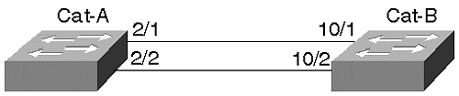
Examples 8-2 and 8-3 show sample configurations for both Cat-A and Cat-B.

Example 8-2 A Two-Port EtherChannel Configuration for Cat-A
Cat-A> (enable) set port channel 2/1-2 on Port(s) 2/1-2 channel mode set to on.

Example 8-3 A Two-Port EtherChannel Configuration for Cat-B
Cat-B> (enable) set port channel 10/1-2 on Port(s) 10/1-2 channel mode set to on.
Tip
Note that when you enable PAgP on a link where Spanning Tree is active, Spanning Tree takes about 18 more seconds to converge. This is true because PAgP takes about 18 seconds to negotiate a link. The link negotiation must be completed before Spanning Tree can start its convergence algorithm.

Tip
If you change an attribute on one of the EtherChannel segments, you must make the same change on all of the segments for the change to be effective. All ports must be configured identically.

EtherChannel and Routers
Enabling EtherChannel on a Cisco router requires you to define a virtual channel and then to associate specific interfaces to the channel. Up to four EtherChannels can be created in a router. The router views the EtherChannel as a single interface. Example 8-4 shows a configuration for a Cisco 7200 series router. You assign logical addresses to a bundle, not to individual segments in the EtherChannel. The router views the EtherChannel as a single interface.

Example 8-4 7200 Series EtherChannel Configuration Session Example
Router# config terminal ! This creates the virtual channel Router(config)# interface port-channel 1 ! Assign attribututes to the channel just like to a real interface. Router(config-if)# ip address 10.0.0.1 255.0.0.0 Router(config-if)# ip route-cache distributed Router(config-if)# exit !Configure the physical interfaces that comprise the channel Router(config)# interface fasteth 0/0 Router(config-if)# no ip address !This statement assigns fasteth 0/0 to the EtherChannel Router(config-if)# channel-group 1 %LINEPROTO-5-UPDOWN: Line protocol on Interface Port-Channel1, changed to UP Router(config-if)# exit !You must have at least two interfaces to form an EtherChannel Router(config-if)# interface fasteth 0/1 Router(config-if)# no ip address Router(config-if)# channel-group 1 FastEthernet 0/1 added as member-2 to fechannel1
In the Catalyst, hardware forms an EtherChannel. In most of the routers, an EtherChannel is formed in software. Unlike the Catalyst, therefore, the router interfaces do not need to be contiguous. However, it might make it administratively easier for you if they are.
Load distribution in a router happens differently than for the Catalyst. Rather than distributing frames based upon the MAC addresses, the router performs an X-OR on the last two bits of the source and destination IP address. Theoretically, you should be able to maintain load balancing with this, but because IP addresses are locally administered (you assign them) you can unintentionally assign addresses with a scheme that might favor one link or another in the EtherChannel. If you have EtherChannel to a router, evaluate your IP address assignment policy to see if you are doing anything that might prevent load distribution. If you use protocols other than IP, all non-IP traffic uses a single link. Only the IP traffic experiences load distribution.
If you have a Layer 3 switch such as the Catalyst 8500 series switch/router, it can perform load balancing based upon the IP address and upon an IPX address. Because IPX incorporates the station's MAC address as part of the logical address, load distribution occurs just like it does for any other Catalyst, based upon the MAC address. As mentioned previously, this ensures a fairly high degree of randomness for load distribution, but cannot guarantee load balancing. A particular workstation/server pair can create a high bandwidth load. All of the frames for that pair always cross the same link—even if another link in the EtherChannel remains unused. Load distribution is not based upon bandwidth utilization.

EtherChannel Resiliency
What happens when an EtherChannel segment fails? When a Catalyst detects a segment failure, it informs the Encoded Address Recognition Logic (EARL) ASIC on the Supervisor module. The EARL is a special application-specific integrated circuit that learns MAC addresses. In essence, the EARL is the learning and address storage device creating the bridge tables discussed in Chapter 3. The EARL ages any addresses that it learned on that segment so it can relearn address pairs on a new segment in the bundle. On what segment does it relearn the source? In a two-segment EtherChannel, frames must cross the one remaining segment. In a four- or eight-segment bundle, traffic migrates to the neighboring segment.
When you restore the failed segment, you do not see the traffic return to the original segment. When the segment fails, the EARL relearns the addresses on a new link. Until addresses age out of the bridge table, the frames continue to cross the backup link. This requires that the stations not transmit for the duration of the bridge aging timer. You can manually clear the bridge table, but that forces the Catalyst to recalculate and relearn all the addresses associated with that segment.

EtherChannel Development
EtherChannel defines a bundling technique for standards-based segments such as Fast Ethernet and Gigabit Ethernet. It does not cause the links to operate at clock rates different than they were without bundling. This makes the segments non Fast Ethernet- or Gigabit Ethernet-compliant. EtherChannel enables devices to distribute a traffic load over more than one segment while providing a level of resiliency that does not involve Spanning Tree or other failover mechanisms. The IEEE is examining a standards-based approach to bundling in the 802.3ad committee.

ISL
When multiplexing frames from more than one VLAN over a Fast Ethernet or Fast EtherChannel, the transmitting Catalyst must identify the frame's VLAN membership. This allows the receiving Catalyst to constrain the frame to the same VLAN as the source, thereby maintaining VLAN integrity. Otherwise, the frame crosses VLAN boundaries and violates the intention of creating VLANs.
Cisco's proprietary Inter-Switch Link (ISL) encapsulation enables VLANs to share a common link between Catalysts while allowing the receiver to separate the frames into the correct VLANs.
When a Catalyst forwards or floods a frame out an ISL enabled trunk interface, the Catalyst encapsulates the original frame identifying the source VLAN. Generically, the encapsulation looks like Figure 8-7. When the frame leaves the trunk interface at the source Catalyst, the Catalyst prepends a 26-octet ISL header and appends a 4-octet CRC to the frame. This is called double-taggingortwo-level tagging encapsulation.

Figure 8-7 ISL Double-Tagging Encapsulation
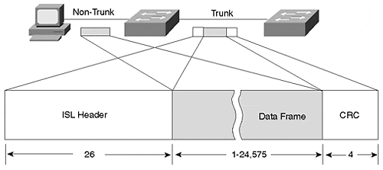
The ISL header looks like that described in Table 8-6.

Table 8-6. ISL Encapsulation Description
Octet | Description
DA | A 40-bit multicast address with a value of 0x01-00-0C-00-00 that indicates to the receiving Catalyst that the frame is an ISL encapsulated frame.
Type | A 4-bit value indicating the source frame type. Values include 0 0 0 0 (Ethernet), 0 0 0 1 (Token Ring), 0 0 1 0 (FDDI), and 0 0 1 1 (ATM).
User | A 4-bit value usually set to zero, but can be used for special situations when transporting Token Ring.
SA | The 802.3 MAC address of the transmitting Catalyst. This is a 48-bit value.
Length | The LEN field is a 16-bit value indicating the length of the user data and ISL header, but excludes the DA, Type, User, SA, and Length and ISL CRC bytes.
SNAP | A three-byte field with a fixed value of 0xAA-AA-03.
HSA | This three-byte value duplicates the high order bytes of the ISL SA field.
VLAN | A 15-bit value to reflect the numerical value of the source VLAN that the user frame belongs to. Note that only 10 bits are used.
BPDU | A single-bit value that, when set to 1, indicates that the receiving Catalyst should immediately examine the frame as an end station because the data contains either a Spanning Tree, ISL, VTP, or CDP message.
Index | The value indicates what port the frame exited from the source Catalyst.
Reserved | Token Ring and FDDI frames have special values that need to be transported over the ISL link. These values, such as AC and FC, are carried in this field. The value of this field is zero for Ethernet frames.
User Frame | The original user data frame is inserted here including the frame's FCS.
CRC | ISL calculates a 32-bit CRC for the header and user frame. This double-checks the integrity of the message as it crosses an ISL trunk. It does not replace the User Frame CRC.
ISL trunk links can carry traffic from LAN sources other than Ethernet. For example, Token Ring and FDDI segments can communicate across an ISL trunk. Figure 8-8 shows two Token Rings on different Catalysts that need to communicate with each other. Ethernet-based VLANs also exist in the network. The connection between the Catalysts is an Ethernet trunk.

Figure 8-8 Using Token Ring ISL (TRISL) to Transport Token Ring Over an Ethernet Trunk
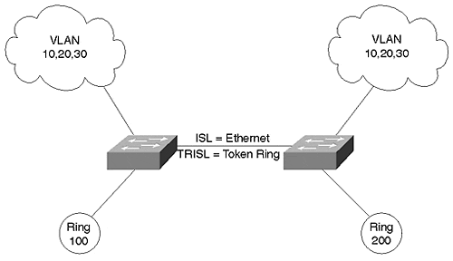
Unfortunately, Token Ring attributes differ significantly from Ethernet. Differences between Token Ring and Ethernet include the following:
- Frame sizes—
Token Ring supports frames both smaller and extremely larger than Ethernet.
- Routing Information Field—
Token Ring frames can include an RIF which is meaningless in an Ethernet system.
- Explorer frames—
Token Ring stations can transmit an explorer frame to discover the relative location of a destination device. This frame type includes a bit indicating that the encapsulated frame is an explorer.
These differences make transporting Token Ring frames over an Ethernet segment challenging at the least.
To effectively transport Token Ring frames over an Ethernet link, the Catalyst must deal with each of these issues.
When Cisco developed ISL, it included a provision for Token Ring and FDDI over Ethernet. The ISL header includes a space for carrying Token Ring- and FDDI-specific header information. These are carried in the Reserved field of the ISL header.
When specifically dealing with Token Ring over ISL, the encapsulation is called Token Ring ISL (TRISL). TRISL adds seven octets to the standard ISL encapsulation to carry Token Ring information. The trunk passes both ISL- and TRISL-encapsulated frames.

Dynamic ISL (DISL)
Two Catalysts interconnected with a Fast Ethernet, Gigabit Ethernet, Fast EtherChannel, or Gigabit EtherChannel can operate in a non-trunk mode using access links. When so configured, the traffic from only one VLAN passes over the link. More often, however, you desire to transport traffic from more than one VLAN over the link. Multiplexing the data from the different VLANs over the link requires ISL as described in the previous section. Both ends must agree upon enabling ISL to successfully trunk over the Fast Ethernet or Fast EtherChannel link. If one end enables ISL and the other end disables ISL, the packet encapsulation mismatch prevents successful user data communication over the link. One end generates encapsulated frames and expects to see encapsulated frames, whereas the other end expects the inverse. Conversely, the non-trunking end transmits unencapsulated frames, whereas the receiving trunking end looks for encapsulation, but does not see it and rejects the frame.
In the earliest versions of Catalyst code, you had to manually enable ISL at both ends of the link. With release 2.1 of the Catalyst software, an automatic method of enabling ISL was introduced requiring you to only configure one end of a link. The Cisco proprietary Dynamic Inter-Switch Link (DISL) protocol enables a Catalyst to negotiate with the remote side of a point-to-point Fast Ethernet, Gigabit Ethernet, or EtherChannel to enable or disable ISL. DISL, a data link layer protocol, transmits ISL configuration information with a destination MAC multicast address of 01-00-0C-CC-CC-CC. Note that Cisco uses this multicast address for several proprietary protocols. Cisco uses a different SNAP value, though, to distinguish the packet's purpose. For example, CDP uses the multicast address and a SNAP value of 0x2000, whereas DISL uses the multicast with a SNAP value of 0x2004. When a Catalyst receives a frame with this destination address, it does not forward the frame out any interface. Rather, it processes the frame on the Supervisor module.
A Catalyst trunk (both Fast Ethernet and Gigabit Ethernet) interface can support one of five trunk modes: off, on, desirable, auto, or nonegotiate. When set to off, on, auto, or desirable, the Catalyst sends ISL configuration frames every 30 seconds to ensure that the other end synchronizes to the current configuration. The syntax to enable trunking is as follows:

set trunk mod_num/port_num [on | desirable | auto | nonegotiate]

Note that off is not listed because it disables trunking as described below.
When configured as off, the interface locally disables ISL and negotiates (informs) the remote end of the local state. If the remote end configuration allows dynamic trunk state changes (auto or desirable), it configures itself as a non-trunk. If the remote side cannot change state (such as when configured to on), the local unit still disables ISL. Additionally, if the local unit is configured as off and it receives a request from the remote Catalyst to enable ISL, the local Catalyst refuses the request. Setting the port to off forces the interface to remain off, regardless of the ISL state at the remote end. Use this mode whenever you don't want an interface to be a trunk, but want it to participate in ISL negotiations to inform the remote side of its local policy.
On the other hand, if the local interface configuration is on, the Catalyst locally enables ISL and negotiates (informs) the remote side of the local state. If the remote side configuration is auto or desirable, the link enables trunking and ISL encapsulation. If the remote end state is off, the link never negotiates to an enabled trunk mode. The local Catalyst enables trunking while the remote end remains disabled. This creates an encapsulation mismatch preventing successful data transfers. Use trunk mode on when the remote end supports DISL, and when you want the local end to remain in trunk mode regardless of the remote end's mode.
The desirable mode causes a Catalyst interface to inform the remote end of its intent to enable ISL, but does not actually enable ISL unless the remote end agrees to enable it. The remote end must be set in the on, auto, or desirable mode for the link to establish an ISL trunk. Do not use the desirable mode if the remote end does not support DISL.
Note
Not all Catalysts, such as the older Catalyst 3000 and the Catalyst 1900, support DISL. If you enable the Catalyst 5000 end as desirable and the other end does not support DISL, a trunk is never established. Only use the desirable mode when you are confident that the remote end supports DISL, and you want to simplify your configuration requirements.

Configuring a Catalyst in auto mode enables the Catalyst to receive a request to enable ISL trunking and to automatically enter that mode. The Catalyst configured in auto never initiates a request to create a trunk and never becomes a trunk unless the remote end is configured as on or desirable. The auto mode is the Catalyst default configuration. If when enabling a trunk you do not specify a mode, auto is assumed. A Catalyst never enables trunk mode when left to the default values at both ends. When one end is set as auto, you must set the other end to either on or desirable to activate a trunk.
The nonegotiate mode establishes a Catalyst configuration where the Catalyst enables trunking, but does not send any configuration requests to the remote device. This mode prevents the Catalyst from sending DISL frames to set up a trunk port. Use this mode when establishing a trunk between a Catalyst and a router to ensure that the router does not erroneously forward the DISL requests to another VLAN component. You should also use this whenever the remote end does not support DISL. Sending DISL announcements over the link is unproductive when the receiving device does not support it.
Table 8-7 shows the different combinations of trunk modes and the corresponding effect.

Table 8-7. Results of Mixed DISL Modes
Local Mode? Remote Mode? | off | on | auto | desirable | nonegotiate
off | Local:off  Remote:off | Local:on  Remote:off | Local:off  Remote:off | Local:off  Remote:off | Local:on  Remote:off
on | Local:off  Remote:on | Local:on  Remote:on | Local:on  Remote:on | Local:on  Remote:on | Local:on  Remote:on
auto | Local:off  Remote:off | Local:on  Remote:on | Local:off  Remote:off | Local:on  Remote:on | Local:on  Remote:off
desirable | Local:off  Remote:off | Local:on  Remote:on | Local:on  Remote:on | Local:on  Remote:on | Local:on  Remote:on
nonegotiate | Local:off  Remote:on | Local:on  Remote:on | Local:off  Remote:on | Local:on  Remote:on | Local:on  Remote:on
With all of these combinations, the physical layer might appear to be operational. If you do a show port, the display indicates connected. However, that does not necessarily mean that the trunk is operational. If both the remote and local sides of the link do not have the same indication (on or off), you cannot transmit any traffic due to encapsulation mismatches. Use the show trunk command to examine the trunk status. For example, in Table 8-7, the combination on/auto results in both sides trunking. The combination auto/auto results in both sides remaining configured as access links. Therefore, trunking is not enabled. Both of these are valid in that both ends agree to trunk or not to trunk. However, the combination on/off creates a situation where the two ends of the link disagree about the trunk condition. Both sides pass traffic, but neither side can decode the received traffic. This is because of the encapsulation mismatch that results from the disagreement. The end with trunking enabled looks for ISL encapsulated frames, but actually receives nonencapsulated frames. Likewise, the end that is configured as an access link looks for nonencapsulated Ethernet frames, but sees encapsulation headers that are not part of the Ethernet standard and interpret these as errored frames. Therefore, traffic does not successfully transfer across the link.
Do not get confused between DISL and PAgP. In the section on EtherChannel, PAgP was introduced. PAgP allows two Catalysts to negotiate how to form an EtherChannel between them. PAgP does not negotiate whether or not to enter trunk mode. This is the domain of DISL and Dynamic Trunk Protocol (DTP). DTP is a second generation of DISL and allows the Catalysts to negotiate whether or not to use 802.1Q encapsulation. This is discussed further in a later section in this chapter. On the other hand, note that DISL and DTP do not negotiate anything about EtherChannel. Rather, they negotiate whether to enable trunking.
Tip
It is best to hard code the trunk configuration on critical links between Catalysts such as in your core network, or to critical servers that are trunk attached.

Tip
If you configure the Catalyst trunk links for dynamic operations (desirable, auto), ensure that both ends of the link belong to the same VTP management domain. If they belong to different domains, Catalysts do not form the trunk link.

802.1Q/802.1p
In an effort to provide multivendor support for VLANs, the IEEE 802.1Q committee defined a method for multiplexing VLANs in local and metropolitan area networks. The multiplexing method, similar to ISL, offers an alternative trunk protocol in a Catalyst network. Like ISL, 802.1Q explicitly tags frames to identify the frame's VLAN membership. The tagging scheme differs from ISL in that ISL uses an external tag, and 802.1Q uses an internal tag.
The IEEE also worked on a standard called 802.1p. 802.1p allows users to specify priorities for their traffic. The priority value is inserted into the priority field of the 802.1Q header. If a LAN switch supports 802.1p, the switch might forward traffic flagged as higher priority before it forwards other traffic.
ISL's external tag scheme adds octets to the beginning and to the end of the original data frame. Because information is added to both ends of a frame, this is sometimes called double-tagging. (Refer back to Table 8-6 for ISL details.) 802.1Q is called an internal tagscheme because it adds octets inside of the original data frame. In contrast to double-tagging, this is sometimes called a single-tag scheme. Figure 8-9 shows an 802.1Q tagged frame.

Figure 8-9 802.1Q/802.1p Frame Tagging Compared to ISL
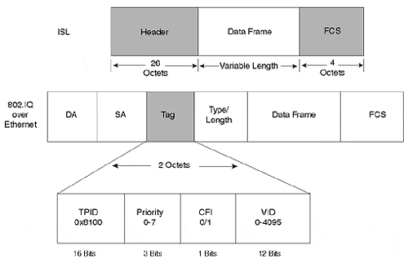
The following bullets describe each of the fields in the 802.1Q header illustrated in Figure 8-9:
- TPID (Tag Protocol Identifier)—
This indicates to the receiver that an 802.1Q tag follows. The value for the TPID is a hexadecimal value of 0x8100.
- Priority—
This is the 802.1p priority field. Eight priority levels are defined in 802.1p and are embedded in the 802.1Q header.
- CFI (Canonical format indicator) —
This single bit indicates whether or not the MAC addresses in the MAC header are in canonical (0) or non-canonical (1) format.
- VID (VLAN Identifier)—
This indicates the source VLAN membership for the frame. The 12-bit field allows for VLAN values between 0 and 4095. However, VLANs 0, 1, and 4095 are reserved.
An interesting situation arises from the 802.1Q tag scheme. If the tag is added to a maximum sized Ethernet frame, the frame size exceeds that specified by IEEE 802.3. To carry the tag in a maximum sized Ethernet frame requires 1522 octets, four more than the specification allows. The 802.3 committee created a workgroup, 802.3ac, to extend Ethernet's maximum frame size to 1522 octets.
If you have equipment that does not support the larger frame size, it might complain if it receives these oversized frames. These frames are sometimes called baby giants.

802.1Q, ISL, and Spanning Tree
When Cisco introduced switched LAN solutions, it recognized the possibility of a complex Catalyst topology. Consequently, Cisco supports multiple instances of Spanning Tree. You can create a different Spanning Tree topology for every VLAN in your network where each VLAN can have a different Catalyst for a Root Bridge. This allows you to optimize the bridged network topology for each VLAN. The selection of a Root Bridge for VLAN 10 might not be the best choice for VLAN 11, or any VLAN other than VLAN 10. Cisco's capability to support multiple instances of Spanning Tree in the Catalyst is called Per-VLAN Spanning Tree (PVST).
802.1Q, however, defines a single instance of Spanning Tree for all VLANs. All VLANs have the same Root Bridge in an 802.1Q network. This is called a Mono Spanning Tree (MST) topology. 802.1Q does not exclude the use of more than one instance of Spanning Tree, it just does not address the issues of how to support it.
A complication could arise in a hybrid ISL and 802.1Q environment. Without any special provisions, you need to restrict your Spanning Tree topology to a common topology for all VLANs. Cisco developed PVST+ which allows you to retain multiple Spanning Tree topologies, even in an 802.1Q mixed vendor environment. PVST+ tunnels PVST frames through the 802.1Q MST Spanning Tree network as multicast frames. Cisco uses the multicast address 01-00-0C-CC-CC-CD for PVST+. Unlike 802.1Q, PVST+ enables you to reuse a MAC address in multiple VLANs. If you have devices that need to do this, you need to use ISL and PVST+. Chapter 7, "Advanced Spanning Tree," provides more details on PVST+.

Configuring 802.1Q
Configuration tasks to enable 802.1Q trunks include the following:
- Specify the correct encapsulation mode (ISL or 802.1Q) for the trunk.
- Enable the correct DTP trunking mode or manually ensure that both ends of the link support the same trunk mode.
- Select the correct native VLAN-id on both ends of the 802.1Q trunk.
The following syntax enables an 802.1Q trunk on a Catalyst:

set trunk mod_num/port_num [on|desirable|auto|nonegotiate] dot1q

dot1q specifies the trunk encapsulation type. Specifically, it enables the trunk using 802.1Q encapsulation. This is an optional field for ISL trunks, but mandatory if you want dot1q. Of course, if you want an ISL trunk, you do not use dot1q, but rather ISL. If you do not specify the encapsulation type, the Catalyst uses the default value (ISL). Not all modules support both ISL and 802.1Q modes. Check current Cisco documentation to determine which modes your hardware supports. Further, not all versions of the Catalyst software support 802.1Q. Only since version 4.1(1) does the Catalyst 5000 family support dot1q encapsulation. Automatic negotiation of the encapsulation type between the two ends of the trunk was not available until version 4.2(1) of the Catalyst 5000 software. 4.2(1) introduced DTP, which is described in the following section. Prior to 4.2(1), you must manually configure the trunk mode.
Example 8-5 shows a sample output for configuring Port 1/1 for dot1q encapsulation. This works whether the interface is Fast Ethernet or Gigabit Ethernet.

Example 8-5 Sample Catalyst Configuration for 802.1Q Trunk
Console> (enable) set trunk 1/1 desirable dot1q Port(s) 1/1 trunk mode set to desirable. Port(s) 1/1 trunk type set to dot1q. Console> (enable) 11/11/1998,23:03:17:DTP-5:Port 1/1 has become dot1q trunk
Enabling 802.1Q trunks on a router is similar to enabling ISL. Like ISL, you must include an encapsulation statement in the interface configuration. Example 8-6 shows a sample router configuration.

Example 8-6 Sample Router Configuration for 802.1Q
! Specify the interface to configure interface fastether 2/0.1 ip address 172.16.10.1 255.255.255.0 ipx network 100 encapsulation dot1q 200
The number at the end of the encapsulation statement specifies the VLAN number. The 802.1Q specification allows VLAN values between 0 and 4095 (with reserved VLAN values as discussed previously). However, a Catalyst supports VLAN values up to 1005. Generally, do not use values greater than 1005 when specifying the 802.1Q VLAN number to remain consistent with Catalyst VLAN numbers. Note that newer code releases allow you to map 802.1Q VLAN numbers into the valid ISL number range. This is useful in a hybrid 802.1Q/ISL environment by enabling you to use any valid 802.1Q value for 802.1Q trunks, while using valid ISL values on ISL trunks.

Dynamic Trunk Protocol (DTP)
802.1Q offers an alternative to Cisco's proprietary ISL encapsulation protocol. That means a Fast Ethernet/EtherChannel link now has even more possible combinations because a trunk can use ISL encapsulation or 802.1Q tags. Just like ISL, 802.1Q trunks can be set for on, off, desirable, or auto. Both ends of a link must, however, be either in ISL or in 802.1Q mode. With version 4.1, you need to manually configure the encapsulation mode at both ends to make them compatible. In release 4.2, Cisco introduced a new link negotiation protocol called Dynamic Trunk Protocol (DTP) which enhances DISL functionality. DTP negotiates the two ends of the link to a compatible mode, reducing the possibility of incompatibly when configuring a link. Note the highlighted DTP message in Example 8-7 indicating that the interface became a trunk. If you select an ISL trunk, DTP reports the action if you have software release 4.2 or later as shown in the output in Example 8-7. Note that PAgP also reports messages. Although PAgP sets up EtherChannel, it reports port status even for non-EtherChannel segments.

Example 8-7 DTP Message When Establishing an ISL Trunk
Port(s) 1/1 trunk mode set to on. Console> (enable) 11/12/1998,17:56:39:DTP-5:Port 1/1 has become isl trunk 11/12/1998,17:56:40:PAGP-5:Port 1/1 left bridge port 1/1. 11/12/1998,17:56:40:PAGP-5:Port 1/1 joined bridge port 1/1

Restricting VLANs on a Trunk
You can elect to restrict what VLANs can cross a trunk. By default, the Catalyst is authorized to transport all VLANs over a trunk. You might want, instead, to allow only VLANs 5–10 over a trunk. You can specify the VLANs to transport as part of the set trunk command. Or, you can remove authorized VLANs from a trunk with the clear trunk command. Example 8-8 shows an example of clearing VLANs from a trunk and adding VLANs.

Example 8-8 Modifying Authorized VLANs on a Trunk
Console> (enable) clear trunk 1/1 10-20 Removing Vlan(s) 10-20 from allowed list. Port 1/1 allowed vlans modified to 1-9,21-1005. Console> (enable) set trunk 1/1 15 Adding vlans 15 to allowed list
At the end of Example 8-8, the complete list of allowed VLANs is 1-9, 15, 21-1005.
You can use these commands on any trunk, regardless of its tagging mode. Note that if you enter these commands on an EtherChannel trunk, the Catalyst modifies all ports in the bundle to ensure consistency. Ensure that you configure the remote link to carry the same set of VLANs.

FDDI Trunks and 802.10 Encapsulation
ISL trunk encapsulation is designed for trunking over a point-to-point connection between two Catalysts using Ethernet. Only two Catalysts connect to the link. This contrasts with connectivity over an FDDI system. FDDI operates as a shared network media (half duplex) and can have more than two participants on the network. A different encapsulation scheme, therefore, is used when trunking over an FDDI network. Cisco adapted an IEEE standard for secure bridging over an 802-based network and applied it to FDDI trunking between Catalysts. IEEE 802.10 devised the standard to facilitate the transport of multiple traffic sources over shared local and metropolitan networks and yet retain logical isolation between the source networks at the receiver.
You can create interconnections between Catalysts where all Catalyst FDDI interfaces belong to the same VLAN. Only one VLAN transports over the FDDI, however. You can do this if you have a simple VLAN design and have an existing FDDI segment that you need to continue to use. The legacy network components might not support 802.10, forcing you to configure your Catalysts so they can share the FDDI network. A more typical use, however, might allow for multiple VLANs to share the backbone, as in Figure 8-10.

Figure 8-10 An FDDI Trunk Example with 802.10 Encapsulation
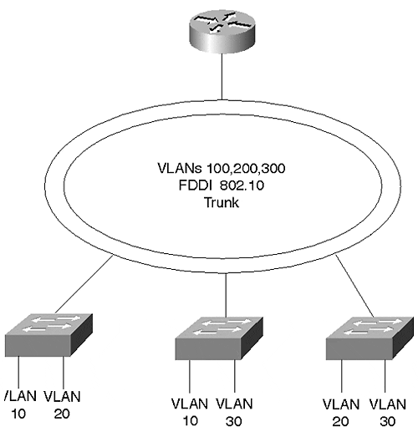
By enabling 802.10 encapsulation on the FDDI interfaces in the network, the FDDI backbone becomes a Catalyst trunk. The network in Figure 8-10 attaches many Catalysts allowing them to transport data from distributed VLANs over the FDDI trunk. Member stations of VLAN 10 on Cat-A can communicate with stations belonging to VLAN 10 on Cat-B. Likewise, members of VLAN 20 can communicate with each other regardless of their location in the network.
As with any multiple VLAN network, routers interconnect VLANs. The Cisco router in Figure 8-10 attached to the FDDI network understands 802.10 encapsulation and can therefore route traffic between VLANs.
The configuration in Example 8-9 demonstrates how to enable 801.10 encapsulation on a Cisco router so that VLAN 100 can communicate with VLAN 200.

Example 8-9 Router Configuration for 802.10 Trunk
int fddi 2/0.1 ip address 172.16.1.1 255.255.255.0 encapsulation sde 100 int fddi 2/0.2 ip address 172.16.2.1 255.255.255.0 encapsulation sde 200
The configuration applies to FDDI subinterfaces. Each VLAN must be configured on a subinterface and should support a single subnetwork. The encapsulation sde 100 statement under subinterface 2/0.1 enables 802.10 encapsulation and associates VLAN 100 with the interface, whereas the statement encapsulation sde 200 associates VLAN 200 with subinterface 2/0.2.
Figure 8-11 illustrates 802.10 encapsulation. The 802.10 header contains the MAC header, a Clear header, and a Protected header. The MAC header contains the usual 48-bit destination and source MAC addresses found in FDDI, Ethernet, and Token Ring networks. The Clear and Protected headers, however, are additions from the 802.10 standard. The Protected header duplicates the source MAC address to ensure that a station is not spoofing the real source. If the source address in the MAC and Protected headers differ, another station took over the session.

Figure 8-11 802.10 Encapsulation
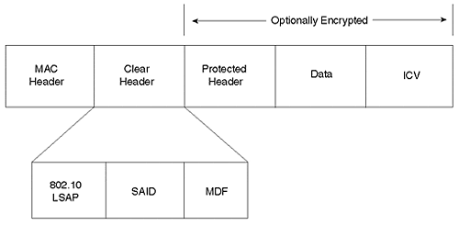
Figure 8-11 shows three fields in the Clear header portion. Only the Security Association Identifier (SAID) field is relevant to VLANs. Therefore, the other two fields (802.10 LSAP and MDF) are ignored in this discussion.
The SAID field as used by Cisco identifies the source VLAN. The four-byte SAID allows for many VLAN identifiers on the FDDI network. When you create an FDDI VLAN, you provide the VLAN number. By default, the Catalyst adds 100,000 to the VLAN number to create a SAID value. The receiving Catalyst subtracts 100,000 to recover the original FDDI VLAN value. Optionally, you can specify a SAID value. But this is not usually necessary. The Catalyst commands in Example 8-10 enable 802.10 encapsulation for VLANs 500 and 600 and modify the VLAN 600 SAID value to 1600.

Example 8-10 802.10 VLAN Configuration
Console> (enable) set vlan 500 type fddi Vlan 500 configuration successful Console> (enable) set vlan 600 type fddi said 1600 Vlan 600 configuration successful
After establishing the VLANs, the show vlan command displays the addition of the VLANs with the specified SAID value as in Example 8-11. Note that VLAN 500 has a SAID value of 100,500 because a SAID value was not specified and the Catalyst by default added 100,000 to the VLAN number.

Example 8-11 show vlan Command Output
Console> (enable) show vlan VLAN Name Status Mod/Ports, Vlans ---- -------------------------------- --------- ------------------------ 1 default active 1/1-2 2/1-24 100 VLAN0100 active 110, 120 110 VLAN0110 active 120 VLAN0120 active 500 VLAN0500 active 600 VLAN0600 active 1002 fddi-default active 1003 trcrf-default active 1004 fddinet-default active 1005 trbrf-default active 1003 VLAN Type SAID MTU Parent RingNo BrdgNo Stp BrdgMode Trans1 Trans2 ---- ----- ---------- ----- ------ ------ ------ ---- -------- ------ ------ 1 enet 100001 1500 - - - - - 0 0 100 trbrf 100100 4472 - - 0x5 ibm - 0 0 110 trcrf 100110 4472 100 0x10 - - srb 0 0 120 trcrf 100120 4472 100 0x20 - - srb 0 0 500 fddi 100500 1500 - 0x0 - - - 0 0 600 fddi 1600 1500 - 0x0 - - - 0 0 1002 fddi 101002 1500 - 0x0 - - - 0 0 1003 trcrf 101003 4472 1005 0xccc - - srb 0 0 1004 fdnet 101004 1500 - - 0x0 ieee - 0 0 1005 trbrf 101005 4472 - - 0xf ibm - 0 0 VLAN AREHops STEHops Backup CRF ---- ------- ------- ---------- 110 7 7 off 120 7 7 off 1003 7 7 off Console> (enable)
Although the FDDI VLANS were successfully created, all that was accomplished was the creation of yet another broadcast domain. The Catalysts treat the FDDI VLAN as distinct from any of the Ethernet VLANs unless you associate the broadcast domains as a single domain. Use the set vlan command to merge the FDDI and the Ethernet broadcast domains. Until you do this, the Catalyst cannot transport the Ethernet VLAN over the FDDI trunk. To make an Ethernet VLAN 10 and an FDDI VLAN 100 part of the same broadcast domain, you enter the following command:

Console> (enable) set vlan 10 translation 100

Conversely, the following command is equally effective, where you specify the FDDI VLAN first, and then translate it into the Ethernet VLAN:

Console> (enable) set vlan 100 translation 10

These are bidirectional commands. You do not need to enter both commands, only one or the other.

ATM Trunks
Asynchronous Transfer Mode (ATM) technology has the inherent capability to transport voice, video, and data over the same infrastructure. And because ATM does not have any collision domain distance constraints like LAN technologies, ATM deployments can reach from the desktop to around the globe. With these attributes, ATM offers users the opportunity to deploy an infrastructure suitable for consolidating what are traditionally independent networks. For example, some companies have a private voice infrastructure between corporate and remote offices. The business leases T1 or E1 services to interconnect private branch exchanges (PBXs) between the offices. The company can deploy or lease a separate network to transport data between the offices. And finally, to support video conferencing, an ISDN service can be installed. Each of these networks has its own equipment requirements, maintenance headaches, and in many cases recurring costs. By consolidating all of the services onto an ATM network, as in Figure 8-12, the infrastructure complexities significantly reduce. Even better, the recurring costs can diminish. Most importantly, this keeps your employer happy.

Figure 8-12 Service Consolidation over an ATM Network
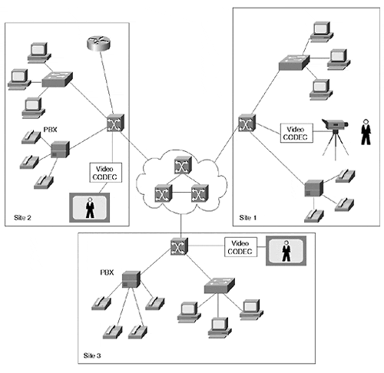
For those installations where ATM provides a backbone service (either at the campus or WAN levels), users can take advantage of the ATM infrastructure to trunk between Catalysts. By inserting a Catalyst LANE module, the Catalyst can send and receive data frames over the ATM network. The Catalyst bridges the LAN traffic onto the ATM network to transport the frames (segmented into ATM cells by the LANE module) through the ATM system and received by another ATM-attached Catalyst or router.
Catalysts support two modes of transporting data over the ATM network: LANE and MPOA. Each of these are covered in detail in other chapters. LANE is discussed in Chapter 9, "Trunking with LAN Emulation," and Chapter 10, "Trunking with Multiprotocol over ATM," covers MPOA operations. The ATM Forum defined LANE and MPOA for data networks. If you plan to use ATM trunking, you are strongly encouraged to visit the ATM Forum Web site and obtain, for free, copies of the LANE and MPOA documents. The following sections on LANE and MPOA provide brief descriptions of these options for trunking over ATM.

LANE
LANE emulates Ethernet and Token Ring networks over ATM. Emulating an Ethernet or Token Ring over ATM defines an Emulated LAN (ELAN). A member of the ELAN is referred to as a LANE Client (LEC). Each ELAN is an independent broadcast domain. An LEC can belong to only one ELAN. Both Ethernet and Token Ring networks are described as broadcast networks; if a station generates a broadcast message, all components in the network receive a copy of the frame. ATM networks, on the other hand, create direct point-to-point connections between users. This creates a problem when a client transmits a broadcast frame. How does the broadcast get distributed to all users in the broadcast domain? ATM does not inherently do this. A client could create a connection to all members of the ELAN and individually forward the broadcast to each client, but this is impractical due to the quantity of virtual connections that need to be established even in a small- to moderately-sized network. Besides, each client does not necessarily know about all other clients in the network. LANE provides a solution by defining a special server responsible for distributing broadcasts within an ELAN.
In Figure 8-13, three Catalysts and a router interconnect over an ATM network. On the LAN side, each Catalyst supports three VLANs. On the ATM side, each Catalyst has three clients to be a member of three ELANs.

Figure 8-13 Catalysts in a LANE Environment Attached to Three ELANs
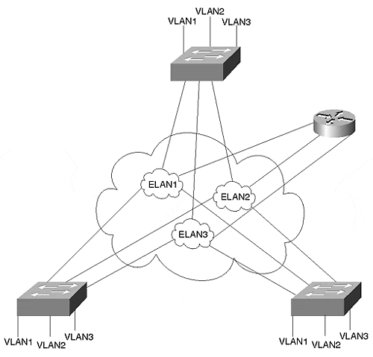
Within the Catalyst configurations, each VLAN maps to one ELAN. This merges the broadcast domains so that the distributed VLANs can intercommunicate over the ATM network. Figure 8-14 shows a logical depiction of the VLAN to ELAN mapping that occurs inside a Catalyst.

Figure 8-14 A Catalyst with Three LECs Configured to Attach to Three ELANs
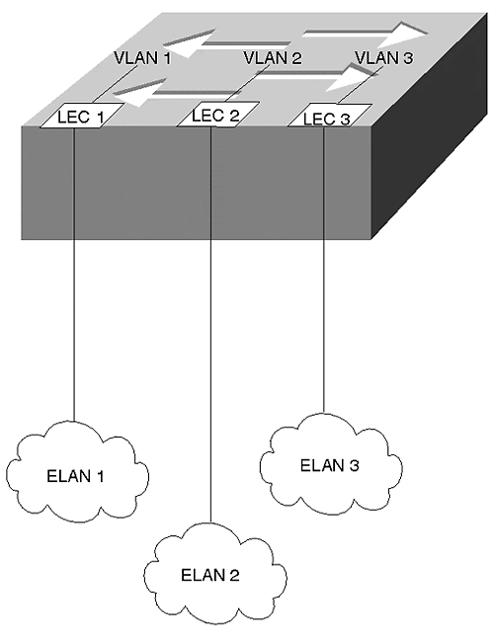
You need the router shown in Figure 8-13 if workstations in one VLAN desire to communicate with workstations in another VLAN. The router can reside on the LAN side of the Catalysts, but this example illustrates the router on the ATM side. When a station in VLAN 1 attempts to communicate with a station in VLAN 2, the Catalyst bridges the frame out LEC 1 to the router. The router, which also has three clients, routes the frame out the LEC which is a member of ELAN 2 to the destination Catalyst. The destination Catalyst receives the frame on LEC 2 and bridges the frame to the correct VLAN port.

MPOA
In most networks, several routers interconnect subnetworks. Only in the smallest networks is a router a member of all subnetworks. In larger networks, therefore, a frame can cross multiple routers to get to the intended destination. When this happens in an ATM network, the same information travels through the ATM cloud as many times as there are inter-router hops. In Figure 8-15, a station in VLAN 1 attached to Cat-A desires to communicate with a station in VLAN 4 on Cat-B. Normally, the frame exits Cat-A toward Router 1, the default gateway. Router 1 forwards the frame to Router 2, which forwards the frame to Router 3. Router 3 transfers the frame to the destination Cat-B. This is the default path and requires four transfers across the ATM network, a very inefficient use of bandwidth. This is particularly frustrating because the ATM network can build a virtual circuit directly between Cat-A and Cat-B. IP rules, however, insist that devices belonging to different subnetworks interconnect through routers.

Figure 8-15 Catalysts in an MPOA Environment
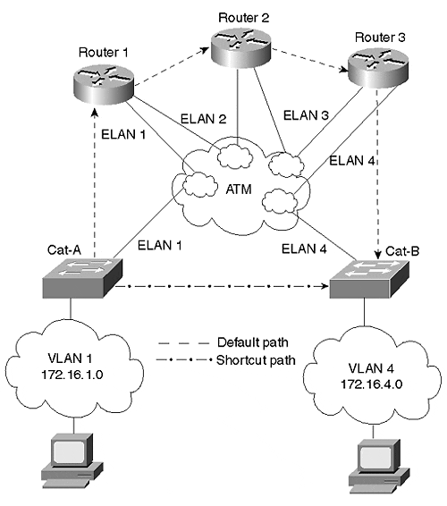
MPOA enables devices to circumvent the default path and establish a direct connection between the devices, even though they belong to different subnets. This shortcut path, illustrated in Figure 8-15, eliminates the multiple transits of the default path conserving ATM bandwidth and reducing the overall transit delay.
MPOA does not replace LANE, but supplements it. In fact, MPOA requires LANE as one of its components. Intra-broadcast domain (transfers within an ELAN) communications use LANE. MPOA kicks in only when devices on different ELANs try to communicate with each other. Even so, MPOA might not always get involved. One reason is that MPOA is protocol dependent. A vendor must provide MPOA capabilities for a protocol. Currently, IP is the dominant protocol supported. Another reason MPOA might not create a shortcut is that it might not be worth it. For MPOA to request a shortcut, the MPOA client must detect enough traffic between two hosts to merit any shortcut efforts. This is determined by an administratively configurable threshold of packets per second between two specific devices. If the client detects a packets per second rate between an IP source and an IP destination greater than the configured threshold, the client attempts to create a shortcut to the IP destination. But if the packets per second rate never exceeds the threshold, frames continue to travel through the default path.

Trunk Options
Three trunk methods and their encapsulation methods were described in the previous sections. Fast Ethernet and Gigabit Ethernet use ISL or 802.1Q encapsulation. FDDI trunks encapsulate with a Cisco proprietary adaptation of 802.10. With ATM, you can use LANE encapsulation. Optionally, you can augment LANE operations with MPOA. Which option should you use?
Criteria you need to consider include the following:
- Existing infrastructure
- Your technology comfort level
- Infrastructure resiliency needs
- Bandwidth requirements

Existing Infrastructure
Your trunk choice might be limited to whatever technology you currently deploy in your network. If your Catalyst interfaces are Ethernet and Fast Ethernet, and your cabling is oriented around that, you probably elect to use some form of Ethernet for your trunk lines. The question becomes one, then, of how much bandwidth do you need to support your users.
If your backbone infrastructure currently runs FDDI, you might not be able to do much with other trunk technologies without deploying some additional cabling. You might need to shift the FDDI network as a distribution network and use another technology for the core backbone. Figure 8-16 shows the FDDI network below the core network.

Figure 8-16 Integrating an Existing FDDI Into Your Network
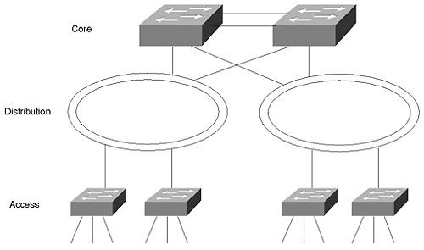
The FDDI segments are dual-homed to core-level Catalysts providing fault tolerance in the event that a primary Catalyst fails. The connection type between the core Catalysts is again determined by the bandwidth requirements. Remember that the FDDI segment is shared. The bandwidth is divided between all of the attached components and operates in half-duplex mode. Today, FDDI is probably your last choice for a backbone technology.
ATM proves to be a good choice if you are interested in network consolidation as described in the ATM trunk section, or if you need to trunk over distances not easily supported by Ethernet or FDDI technologies.

Your Technology Comfort Level
Another consideration might be your personal experience with the network technologies. Although you might not want to admit to your employer that you are uncomfortable with a particular technology because you do not have experience with or knowledge of it, the reason is still valid. Obviously, you prefer to select a technology based solely on technology merits. But, you are the one who needs to fix the network at 2:30 AM when the network fails. Stick with what you know unless there is an absolutely compelling technical reason to do otherwise.

Infrastructure Resiliency Needs
By definition, a lot of users depend upon trunk availability. A trunk carries traffic from more than one VLAN and can, in fact, carry traffic from all VLANs. If a trunk fails between critical points in the network, services become unreachable, causing your pager and/or phone to go off. This is not a desirable event. You might, therefore, need to consider how each of the trunk methods operate in the presence of failures.
The good news is that each of the trunk technologies have resiliency capabilities. The difference between them, however, is deployment requirements and failover times.

FDDI Resiliency
FDDI probably has the quickest failover rate because its resiliency operates at Layer 1, the physical layer. FDDI operates in a dual counter-rotating ring topology. Each ring runs in the opposite direction of the other ring. If a cable breaks between Cat-A and Cat-B as in Figure 8-17, both Catalysts see the loss of optical signal and enter into a wrapped state. Data continues to flow between all components in the network in spite of the cable outage. The cutover time is extremely fast because failure detection and recovery occur at Layer 1.

Figure 8-17 FDDI Resiliency
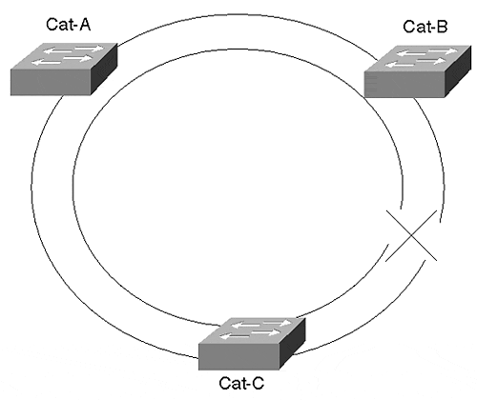

ATM Resiliency
ATM also provides physical layer recovery. However, the failover time is longer than for FDDI. In an ATM network, a cable or interface failure can occur at the Catalyst or between ATM switches. If the failure occurs between ATM switches, the Catalyst requests the ATM network to re-establish a connection to the destination client(s). The ATM network attempts to find an alternate path to complete the connection request. This happens automatically. Figure 8-18 shows a Catalyst attached to two ATM switches for redundancy. One link, the preferred link, is the active connection. The second link serves as a backup and is inactive. Traffic only passes over the active link.

Figure 8-18 Catalyst ATM Resiliency
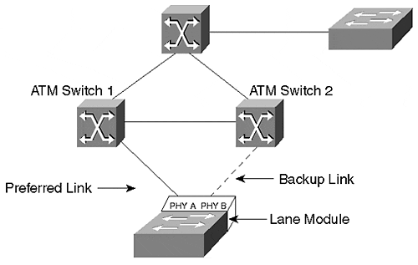
A failure can occur at the Catalyst. To account for this, the Catalyst LANE module provides two physical interfaces, PHY A and PHY B. In Figure 8-18, a Catalyst attaches to two ATM switches. PHY A attaches to ATM Switch 1 and PHY B attaches to ATM Switch 2. The Catalyst activates only one of the interfaces at a time. The other simply provides a backup path. If the active link fails, the Catalyst activates the backup port. The Catalyst must rejoin the ELAN and then reattach to the other client(s) in the network. Although ATM connections can establish quickly, the additional complexity increases the failover time as compared to FDDI links. The actual failover time varies depending upon the tasks that the ATM switches are performing when the Catalyst requests a connection to the ELAN or to another client.
Other types of failures can also occur in a LANE environment. For example, various server functions must be enabled for LANE to function. The LANE version 1 standard provides for only one of the servers in each ELAN. If these servers fail, it disables the ELAN. Cisco has a protocol called Simple Server Redundancy Protocol (SSRP) that enables backup servers so that the LANE can remain functional in the event of a server failure. This is discussed in more detail in Chapter 9, "Trunking with LAN Emulation."

Ethernet Resiliency
Ethernet options (both Fast Ethernet and Gigabit Ethernet) rely upon Spanning Tree for resiliency. Spanning Tree, discussed in Chapter 6, "Understanding Spanning Tree," operates at Layer 2, the data link layer. Components detect failures when they fail to receive BPDUs from the Root Bridge. Spanning Tree recovery can take as much as 50 seconds depending upon at what values you set the timers.
EtherChannel, both Fast and Gigabit, provide local resiliency. Figure 8-19 shows two Catalysts interconnected with an EtherChannel.

Figure 8-19 EtherChannel Resiliency
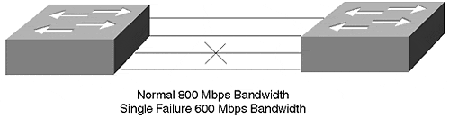
An EtherChannel has more than one link actively carrying data. If one of the links in Figure 8-19 fails, the remaining link(s) continue to carry the load, although with a reduced aggregate bandwidth. This happens without triggering any Spanning Tree events. Therefore, Spanning Tree times do not get involved. Failover for EtherChannel occurs quickly, because it uses Layer 1 failure detection and recovery. If you implement redundant EtherChannels, Spanning Tree activation times must be anticipated.

Resiliency: Failover Mechanisms
One final thought on resiliency. Many network engineers pride themselves in their forethought regarding failover mechanisms. They implement redundant interfaces, taking into account bandwidth planning in failover configurations. They even plan redundant power supplies. And yet they fail to recognize two particular failure modes: power source failures and cable plant routing. Although the redundant supplies can take care of internal equipment supply failures, to be fully protected, the redundant supplies should be attached to alternate sources on different circuit breakers in the facility. If both supplies attach to the same source and that source fails, the whole unit becomes dysfunctional. Place them on redundant sources!
An even more egregious error concerns cable paths. Although you can deploy redundant cable segments, make sure the segments take diverse paths! For example, if you deploy EtherChannel between Catalysts and the cable bundle is cut, the EtherChannel cannot carry data. The electrons fall on the floor. To provide full resiliency, use cable segments from different bundles, through different cable trays and patch panels, through different risers and conduits. Otherwise, if they are all in the same bundle, you are likely to lose the whole connection. Bundles get cut, not individual wires.

Bandwidth Requirements
Right or wrong, network engineers most often use bandwidth capabilities for selecting a trunk technology. Catalyst offers a spectrum of options ranging from half-duplex FDDI through full-duplex Gigabit EtherChannel. Figure 8-20 illustrates a number of Fast Ethernet and Fast EtherChannel options with increasing bandwidth.

Figure 8-20 Bandwidth Options for Ethernet-Based Trunks
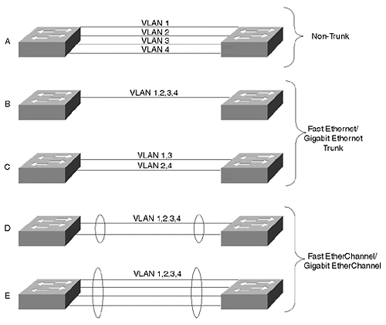
Part A of Figure 8-20 shows an interconnection where each link is dedicated to a VLAN. No trunk encapsulation is used and frames are transported in their native format. Only one link per VLAN between the Catalysts can be active at any time. Spanning Tree disables any additional links. Therefore, bandwidth options are only 10/100/1000 Mbps.
By enabling ISL trunking, you can share the link bandwidth with multiple VLANs. A single Fast Ethernet or Gigabit Ethernet link as in Part B of Figure 8-20 offers 100 or 1000 Mbps bandwidth with no resiliency. Running multiple trunks in parallel provides additional bandwidth and resiliency. However, VLAN traffic from any single VLAN can only use one path while the other path serves as a backup. For example, in Part C of Figure 8-20, two links run between the Catalysts. One link carries the traffic for VLANs 1 and 3, and the other link carries the traffic for VLANs 2 and 4. Each serves as a Spanning Tree backup for the other. This provides more bandwidth than in Part B of Figure 8-20 by having fewer VLANs contend for the bandwidth while providing another level of resiliency. However, each VLAN can still have no more than 100 or 1000 Mbps of bandwidth, depending upon whether the link is Fast Ethernet or a Gigabit Ethernet.
On the other hand, the VLANs in Parts D and E of Figure 8-20 share the aggregate bandwidth of the links. These links use Fast or Gigabit EtherChannel. With a two-port EtherChannel, the VLANs share a 400/4000 Mbps bandwidth. (Each link is full duplex.) A four-port version has 800/8000 Mbps bandwidth.
Table 8-8 compares the various interconnection modes providing a summary of the bandwidth capabilities, resiliency modes, and encapsulation types.

Table 8-8. A Comparison of Different Trunk Modes
Trunk Mode | Bandwidth (Mbps) | Resiliency | Encapsulation | Comments
Per VLAN link | Dedicated per VLAN 10/100/1000 | Spanning Tree | None | VLANs traffic dedicated per link.
Ethernet | Shared 100/1000 | Spanning Tree | ISL/802.1Q | Bandwidth reflects half duplex. Full duplex doubles bandwidth.
EtherChannel | Shared 200/400/2000/8000 | Layer 1 | ISL/802.1Q | Spanning Tree might activate in some cases.
FDDI | Shared 100 | Layer 1 wrap | 802.10
ATM | Shared 155/622 | Layer 1 Diverse path | LANE/MPOA | Resiliency against network and local failures.

Review Questions
This section includes a variety of questions on the topic of campus design implementation. By completing these, you can test your mastery of the material included in this chapter as well as help prepare yourself for the CCIE written test.
1: | What happens in a traffic loading situation for EtherChannel when two servers pass files between each other?
2: | If you have access to equipment, attempt to configure a two-segment EtherChannel where one end is set to transport only VLANs 1–10 and the other end of the segment is set to transport all VLANs. What gets established?
3: | In Figure 8-13, the configuration shows an 802.1Q encapsulation for VLAN 200 on a router. How would you add VLAN 300 to the trunk?
4: | Configure a Catalyst trunk to transport VLAN 200 and VLAN 300 with 802.1Q. Repeat the exercise with ISL.

